**Summary of all 3 WTC-3 papers**

**John’s paper (in preparation):**

The key question are:

- Does experimental warming or experimental water limitation alter the partitioning (allocation!) of photosynthesis?

- The key data are the proportional allocation of GPP to aboveground NPP, aboveground Ra, and the residual (belowground C allocation)

Hypotheses:

1. Warming will decrease belowground C allocation (**supported by DA**) by increasing aboveground sink strength, possibly via a stimulation of soil N cycling

2. Water limitation will increase belowground C allocation (**partially supported by DA**) by altering allocation towards water acquisition

Findings:

- ***In contrast with John’s analysis, we consider the treatments to be separated from the beginning of the experiment (n=3) to avoid the pre-treatment effect. And our results show strong pre-treatment differences before drought implementation.***

- GPP was strongly increased by experimental warming early in the experiment (+22%, P < 0.01), but GPP between ambient and warmed treatments converged at the beginning in the Austral Summer (late January; Fig. 5a) : ***our analysis agrees with this.***

- The drought treatment modestly reduced GPP in both temperature treatments (15%, P < 0.01). These results follow the net C flux measurements (Fig. 2ac) : ***similar findings from our analysis.***

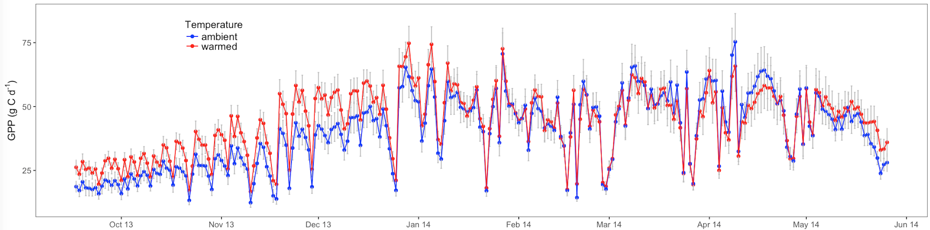

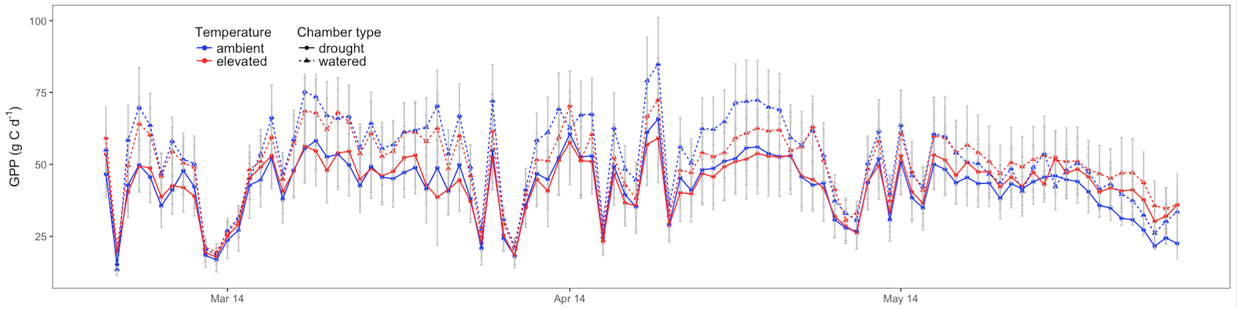

- The response of Ra (Fig. 5c) also followed GPP, with a strong stimulation by warming early in the experiment (+39%, P < 0.01) : ***we find the increase continues over the whole experiment, slightly low though in later part.***

- And a modest reduction with drought that was equivalent across temperature treatments (13%, P < 0.05) : ***agreed.***

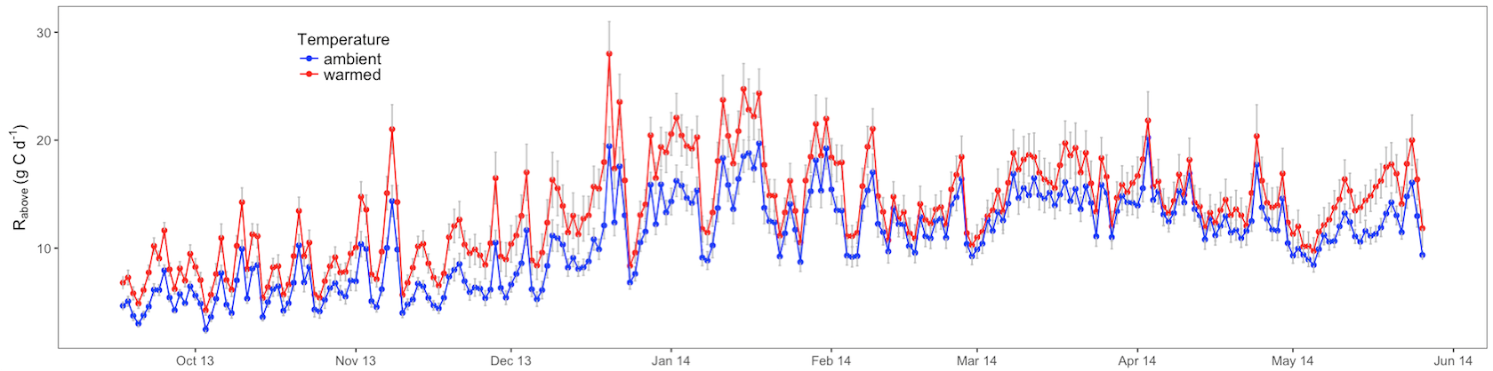

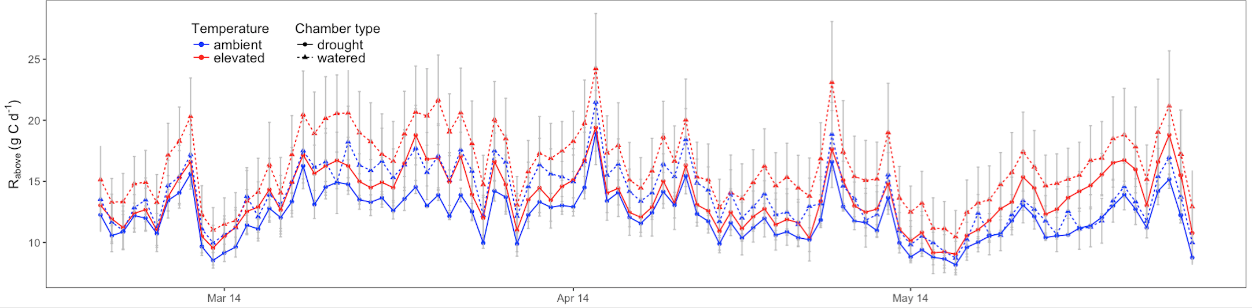

- Experimental warming increased growth during cool periods, but reduced growth during warm periods (Fig. 1): ***kind of supported by our DA analysis. The k values remain similar till Jan for both ambient and warmed treatments, representing higher growth till Jan due to increased amount of photosynthesis in warm condition. The k falls afterwards for the warmed treatment, showing growth reduction in favour of other costs.***

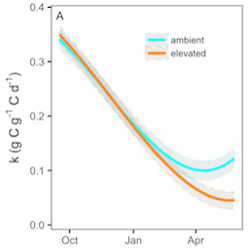

- The allocation of C belowground, as measured by the residual, was decreased by experimental warming throughout the experiment (11%, P < 0.05)***- perfectly agreed by DA***; and was unchanged by the drought treatment (+3%, P > 0.1; Fig. 5d)***- different response from DA (drought decreased the root allocation for warmed treatment with opposite response to ambient treatment).***

- Experimental warming reduced the root mass ratio, while experimental drought increased the root mass ratio, but only in the ambient temperature treatment (Fig. 3b)***: nicely agreed with DA (root allocation, ar).***

- Experimental warming increased the partitioning of GPP to aboveground components and decreased partitioning below ground ***: totally supported by DA.***

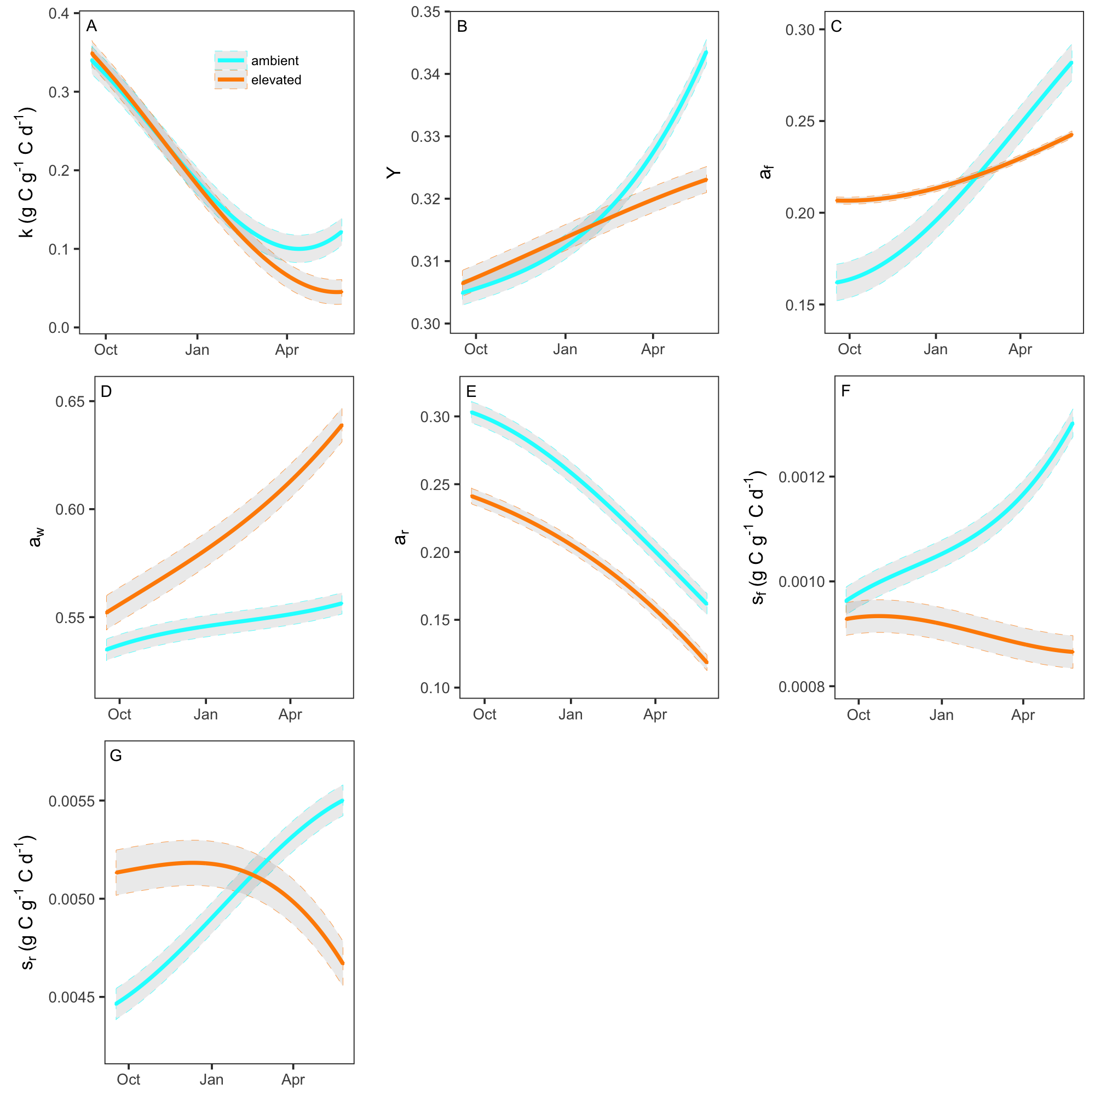

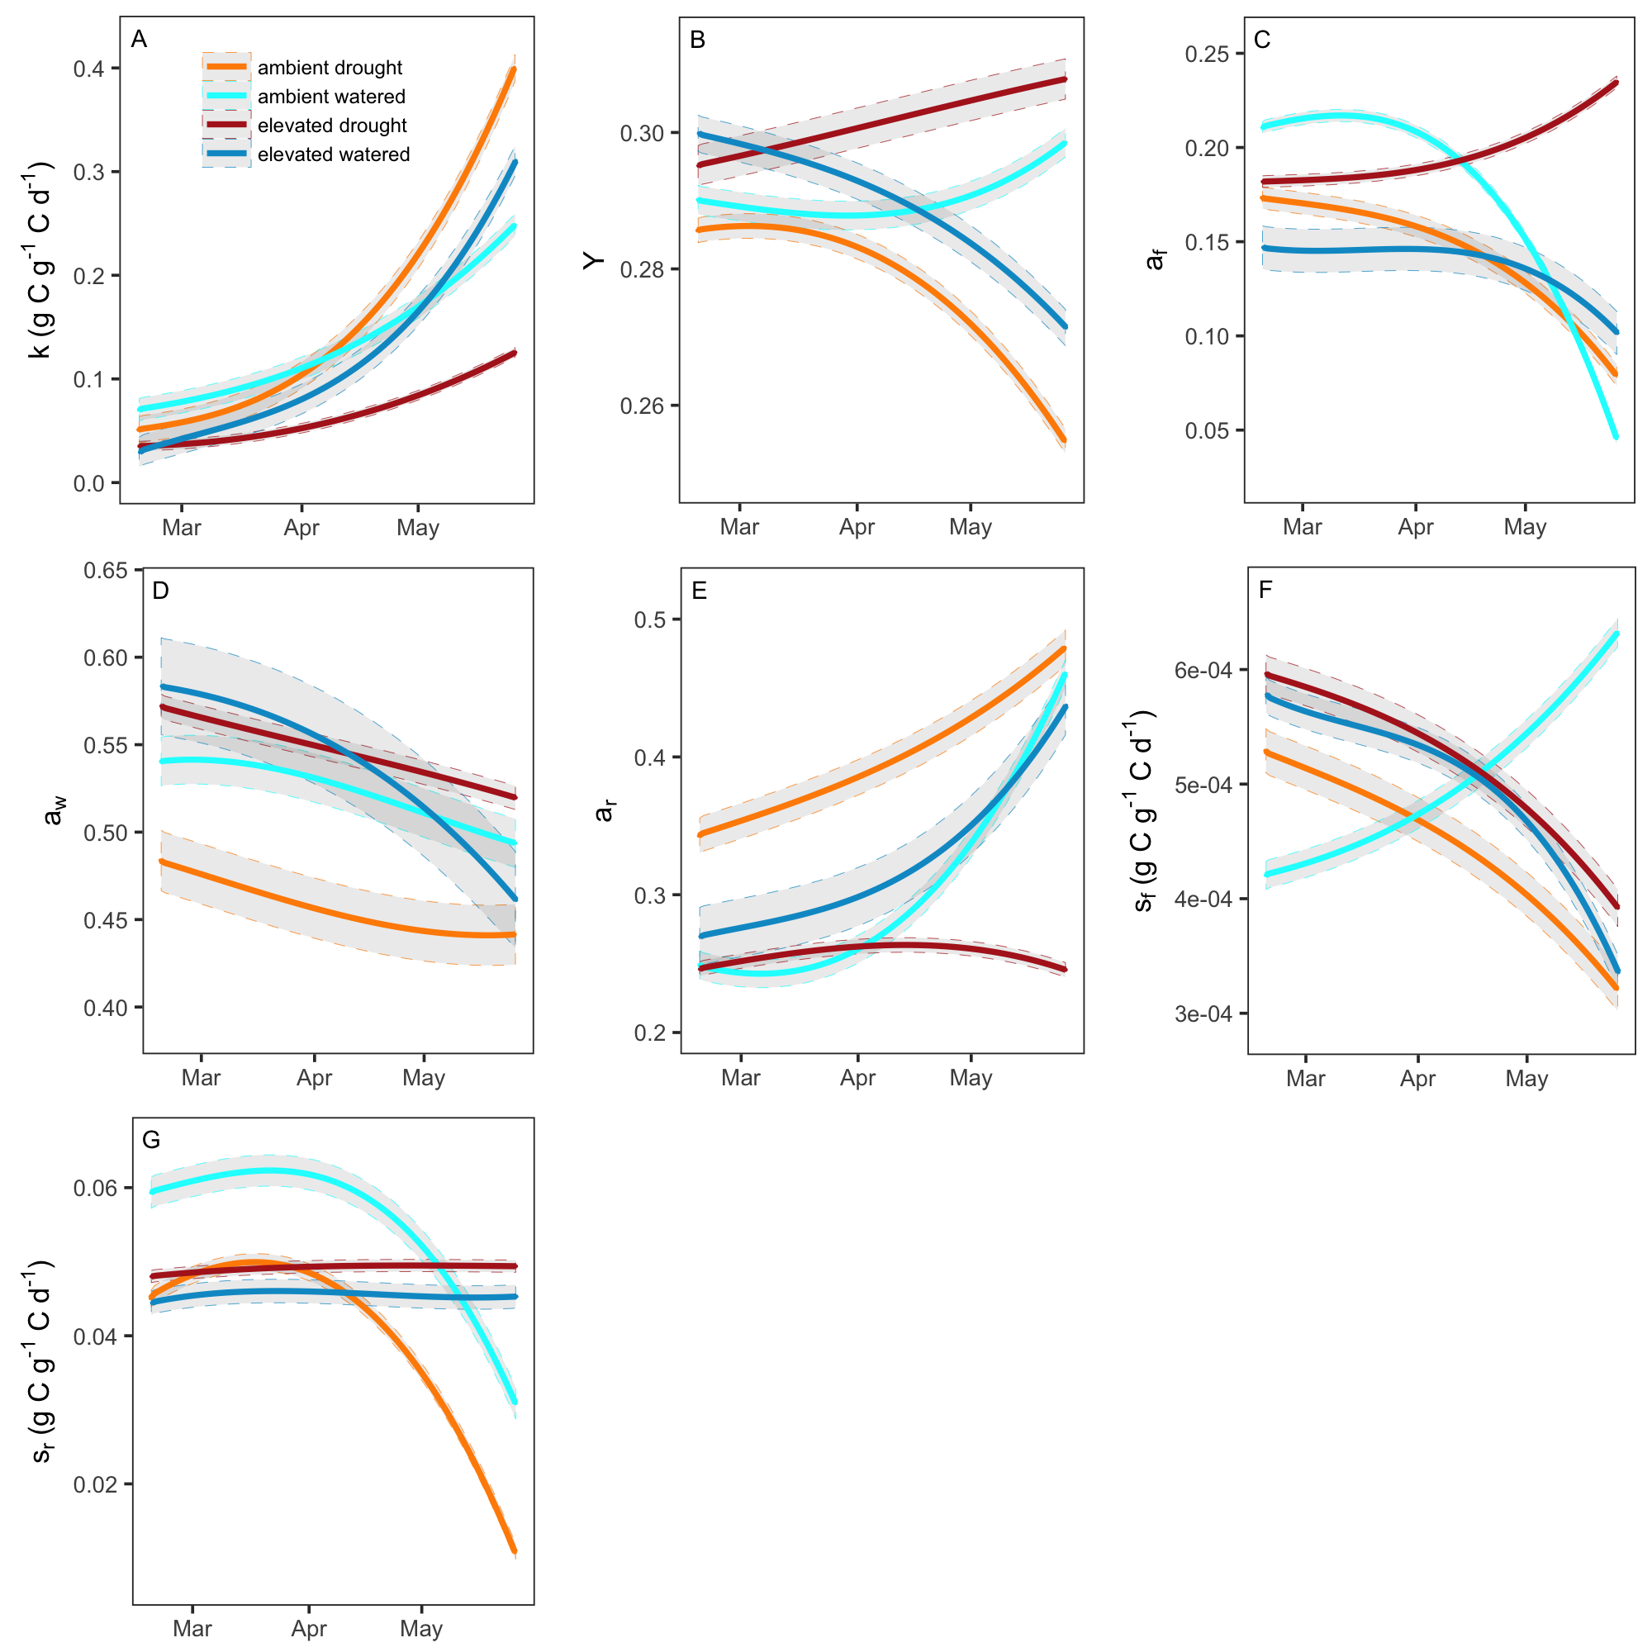

**Drake et al. (2016) New Phyt:**

- Drake et al. (2016) discussed about Ra, GPP and Ra/GPP time series. They found GPP per unit leaf area declined with increasing temperature at the hourly and daily scales, in contrast with their hypothesis.

- The negative temperature dependence of GPP observed at high light contrasts with the classic peaked relationship between photosynthesis and temperature (Sage & Kubien, 2007; Way & Yamori, 2014). This disparity may be related to light availability.

- GPP and Ra per unit leaf area were reduced in the warmed treatment relative to the ambient treatment (95% confidence intervals do not overlap). This correlated reduction in GPP and Ra with warming at any given temperature resulted in a relationship between Ra/GPP and Tair that did not differ between the treatments. Thus, Ra/GPP had a strong temperature dependence that was equivalent across treatments; experimental warming of +3°C did not alter Ra/GPP at any given temperature because the reduction in GPP and Ra with warming were correlated and of a similar magnitude.

**Aspinwall et al. (2016) New Phyt:**

Aspinwall et al. (2016) measured:

- Throughout a 14-month period, monthly leaf-level rates of light saturated A and night-time R at prevailing ambient temperatures, as well as R and light- and CO2 -saturated A at a set temperature of 25°C to assess respiratory and photosynthetic temperature acclimation. They also determined leaf N and TNC concentrations of the measured leaves.

Aspinwall et al. (2016) found that:

- Acclimation of A and R to seasonal temperature change was equivalent to physiological acclimation to climate warming. Moreover, changes in leaf TNC concentrations (but not leaf N) were related to thermal acclimation of both processes, indicating a connection between photosynthesis, carbohydrate availability and respiration.

- Warming reduced rates of Amax and R measured at 25°C compared to ambient-grown trees. Both traits also declined as mean daily Tair increased, and did so in a similar way across temperature treatments. Amax and R (at 25°C) both increased as TNC concentrations increased seasonally; these relationships appeared to arise from source–sink imbalances, suggesting potential substrate regulation of thermal acclimation.

- Photosynthesis and respiration each acclimated equivalently to experimental warming and seasonal temperature change of a similar magnitude, reflecting a common, nearly homeostatic constraint on leaf carbon exchange that will be important in governing tree responses to climate warming.